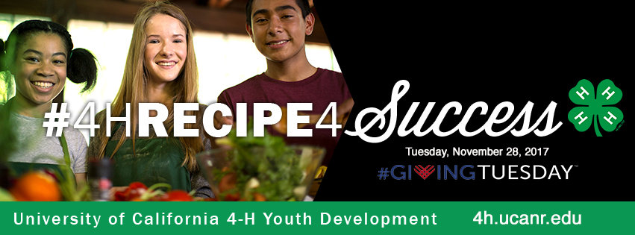

#GivingTuesday
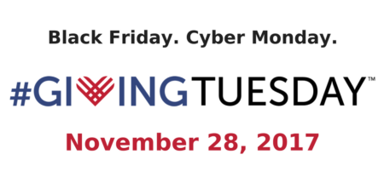
#GivingTuesday is a time for the world to come together & show how powerful humanity can be when we unite to give on one day. Join a movement to celebrate giving and encourage more, better and smarter giving during the holiday season. Learn more about this global day of giving at www.givingtuesday.org.

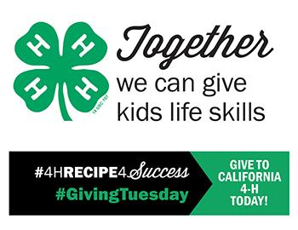

Only donations received on #GivingTuesday,
November 28, 2017 will be eligible
for matching funds, while available.

Help spread the word
