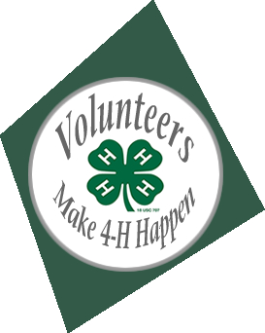
4-H Leadership Adult & Senior Member Conference
Door Prizes
June 16, 2018
Location: Vets Building, 649 San Benito St, Hollister, CA 95023
Check In: 9:00 am
Event from 9:00 am to Noon
The 4-H Leadership Conference is offering 4 workshops. Each workshop will be presented twice during the conference.
The 4-H leadership conference will offer the following workshops:
- Record Book Workshop
- Recruiting & Training New Volunteers Workshop
- How to support or become a Community 4-H Club Leader Workshop
- Social Media & Technology Workshop
Refreshments will be served.
Register online at: https://ucanr.edu/survey/survey.cfm?surveynumber=24649
For More Information contact: Kate Butler at sweetadeline416@gmail.com
ANR NONDISCRIMINATION AND AFFIRMATIVE ACTION POLICY STATEMENT FOR UNIVERSITY OF CALIFORNIA SINGLE PAGE FLYERS FOR EDUCATIONAL PROGRAMS ONLY May, 2015 The following statement is the updated version to be used on single page publications advertising educational programs only. It is the policy of the University of California (UC) and the UC Division of Agriculture & Natural Resources not to engage in discrimination against or harassment of any person in any of its programs or activities (Complete nondiscrimination policy statement can be found at http://ucanr.edu/sites/anrstaff/files/215244.pdf ) Inquiries regarding ANR’s nondiscrimination policies may be directed to John I. Sims, Affirmative Action Compliance Officer/Title IX Officer, University of California, Agriculture and Natural Resources, 2801 Second Street, Davis, CA 95618, (530) 750- 1397.

